Frontend Folder Structure

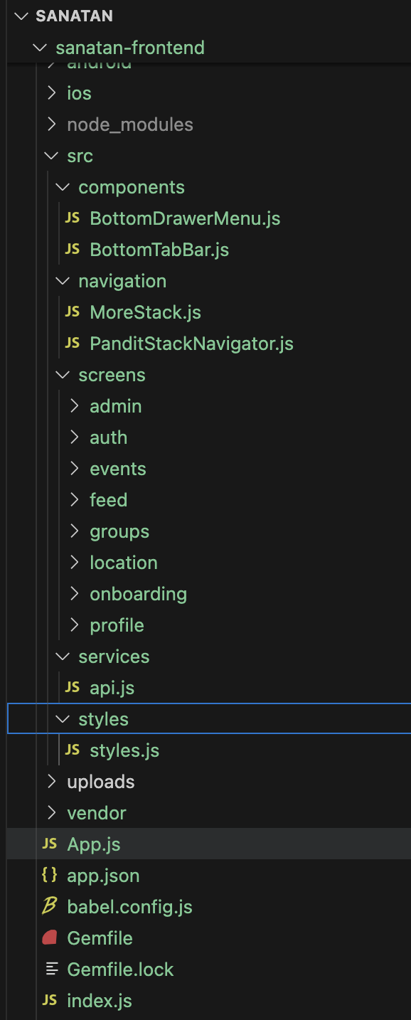

Backend Folder Structure

